RLS TUTORING, INC
SUMMER CAMP, 2017
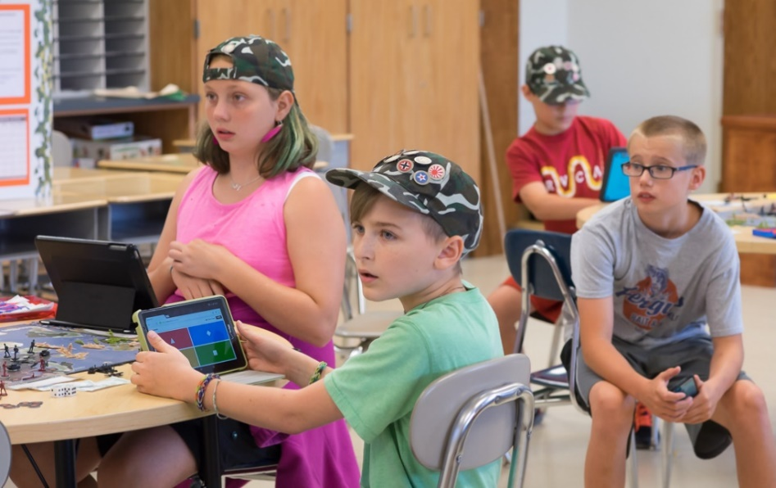
Name of child __________________________ Grade (Fall, 2017) _________
Parent’s Name _________________________________________________
Address _____________________________________________________
City___________________________ State_____________ Zip_________
Email Address_________________________________________________
Phone number(s)________________________________________________
Please indicate the following camp(s) you are registering your child for:
June 5 – 9 Holy Cross Catholic School, 2300 Main St. Batavia, IL 60510
_______Military Games Gr. 5-8 9:00 AM – 12:00 PM $165.00
_______STEM Camp Gr. 2-3 10:00 AM – 12:00 PM $110.00
_______STEM Camp Gr. 4-5 10:00 AM – 12:00 PM $110.00
_______Pirate Adventure Gr. 2-4 12:30 PM – 2:30 PM $110.00
_______STEM Camp Gr. 6-8 12:30 PM – 3:30 PM $165.00

June 19 – 23 St. Peter School, 1881 Kaneville Rd., Geneva, IL 60134
_______HSPT Camp Gr. 6-8 9:00 AM – 12:00 PM $165.00
_______Reading Camp Gr. 2-3 10:00 AM – 12:00 PM $110.00
_______Reading Camp Gr. 4-5 10:00 AM – 12:00 PM $110.00
_______Chess for Beginners Gr. 2-8 10:00 AM – 12:00 PM $110.00
_______Reading Camp Gr. 6-8 12:30 PM – 2:30 PM $110.00
_______Intermediate Chess Gr. 2-8 12:30 PM – 2:30 PM $110.00

June 26 – 30 Holy Cross Catholic School, 2300 Main St. Batavia, IL 60510
_______Advanced Military Games Gr. 5-8 9:00 AM – 12:00 PM $165.00
_______Math Camp Gr. 6-8 9:00 AM – 12:00 PM $165.00
_______Settlers and City Builders Gr. 6-8 12:30 PM – 3:30 PM $165.00
_______The Case of the Missing
Teddy Bear Gr. 2-4 12:30 PM – 2:30 PM $110.00

July 10 – 14 Holy Cross Catholic School, 2300 Main St, Batavia, IL 60510
_______Showstoppers Theater Gr. 2-4 10:00 AM – 12:00 PM $110.00
_______Study Skills Gr. 5-8 10:00 AM – 12:00 PM $110.00
_______Showstoppers Theater Gr. 5-8 12:30 PM – 2:30 PM $110.00
_______The Case of the Missing Lunch Gr. 5-8 12:30 PM – 2:30 PM $110.00

Parent Signature____________________________________ Date____________________

Please make checks out to:
RLS Tutoring, Inc.
410 Moorfield, Ave.
North Aurora, IL 60542

